
Data Structures and Algorithms (23CSE203)
LAB MANUAL
Submitted By:

Name | R . Hasini shekhar
Roll No | AV.SC.U4CSE25146
Year/Sem/Section | 2nd YEAR/SEM-3/CSE-B
Date of Submission:
Submitted To:
Name | Dr. Raj Kumar Batchu
Department | CSE
Designation | Assistant Professor (Sl. Gr) School of Computing

MARKS

S. No | TITLE | PAGE NO | REMARKS
1. | 1(A) Aim:  A rocket launch system displays countdown before launch . Using recursion write python program to display countdown to 1 followed by launch.  1(B) Aim:  Write a python program to calculate compound interest by taking user input.  1(C) Aim:  HR Department stores Employee Id’s in a list develop a recursive program in python to search for a given employee Id in the list.  1(D) Aim:  Develop a python program to print 1st n terms of Fibonacci series.  1(E) Aim:  Develop a python program to calculate factorial of a given number. | 8-15
2. | 2(A) Aim:  Write a python program to implement linear search.  2(B)(i) Aim: Write a python program to implement binary search with sorted array as input.  (ii) Aim: Write a python program to implement binary search with unsorted array as input. | 16 - 21
3. | 3(A) Aim:  Write a python program to apply insertion sort where input elements are taken from the user .  3(B) Aim:  Write a python program to apply bubble sort where input elements are taken from the user .  3(C) Aim:  Write a python program to apply selection sort where input elements are taken from the user . | 22 – 24
4. | 4(A) Aim:  4(A) Aim:  write a python program to implement merge sort, where the elements are taken from user.  4(B) Aim:  write a python program to implement quick sort, where the elements are taken from user.
5. | 5(A) Aim:  Write a python program to implement a single linked list with the below operations:  A. create linked list  B. insert at beginning  C. Insert at end  D. Insert at index  E. Delete by value  F. Delete first node  G. Delete last node  H. Count number of nodes I. Display/traverse  J. exit  5(B) Aim:  Write a python program to implement a double linked list with the below operations:  A. create linked list  B. insert at beginning  C. Insert at end  D. Insert at index  E. Delete by value  F. Delete first node  G. Delete last node  H. Count number of nodes  I. Display/traverse  J. exit  5(C) Aim  Write a python program to implement a circular linked list with the below operations:  A. create linked list  B. insert at beginning  C. Insert at end  D. Insert at index  E. Delete by value  F. Delete first node  G. Delete last node  H. Count number of nodes  I. Display/traverse  J. exit
6. | 6(A) Aim  Write a python program to implement stack operations such as push, pop, peek, display using an array.  6(B) Aim  Write a python program to implement stack operations such as push, pop, peek, display using linked list.
7. | 7(A) Aim  Write a python program to implement queue and its operations such as enqueue, dequeue, peek and display with a menu driven approach using an array.  7(B) Aim  B) Write a python program to implement queue and its operations such as enqueue, dequeue, peek and display with a  Circular queue
8.

9.

LAB-1:
1.)Basic Programs Using Recursions :
A.) Aim: A rocket launch system displays countdown before launch . Using recursion write python program to display countdown to 1 followed by launch.
Program:
def rocket_countdown(n):
if n == 0:
print("LAUNCHED! ")
return

print(n)

rocket_countdown(n - 1)

start_num = int(input("Enter starting countdown number: "))

print("\n--- Starting Countdown ---")
rocket_countdown(start_num)

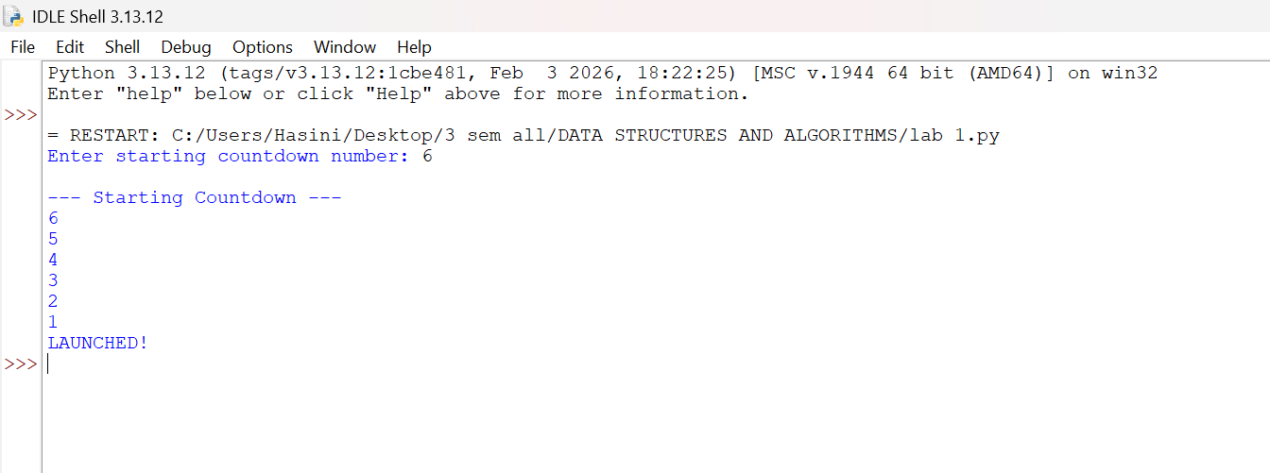
Output(+Ve Case):

Output(-Ve Case):

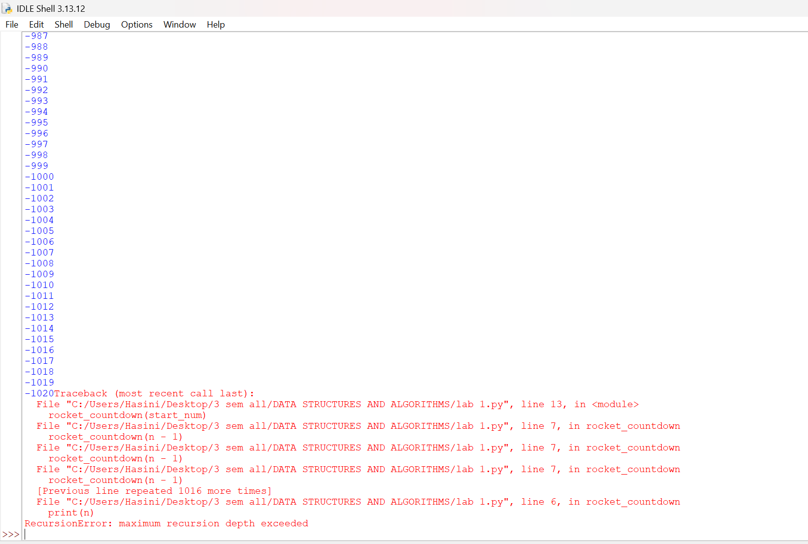

Explanation : This negative scenario has occurred due to infinite recursion . Countdown should never start from -ve integers as decrement will lead to negative infinity and the program crashes.

B.) Aim: Write a python program to calculate compound interest by taking user input.
Program:
def C_Int(p,n,r,t):
decimal_rate = r/100
total_amount = p*(1+decimal_rate/n)**(n*t)
interest_earned = total_amount - p
return total_amount, interest_earned

p = int(input("Enter the principal amount (₹) : "))
n = int(input("Times compounded per year : "))
r = float(input("Enter the annual interest rate (%) : "))
t = float(input("Enter the number of years : "))

final_balance, pure_interest = C_Int(p, n, r, t)

print("\n--- Financial Breakdown ---")
print(f"Interest Earned: ₹{pure_interest:.2f}")
print(f"Total Balance: ₹{final_balance:.2f}")

Output(+Ve Case):

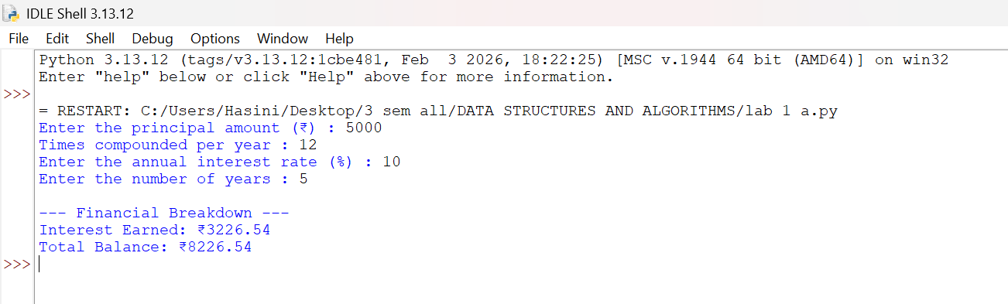

Output(-Ve Case):

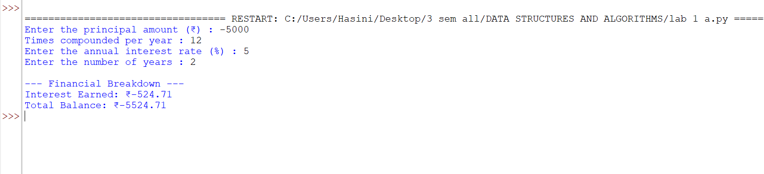

Explanation : Financial values such as Principal Amount, Rate of interest , Number of years should never be allowed to be negative this program projects a just output if and only if all of the input values are +ve.

C.) Aim: HR Department stores Employee Id’s in a list develop a recursive program in python to search for a given employee Id in the list.
Program:
def rec_bin_search(arr,key,low,high):
if low > high :
return -1
mid = (low+high)//2

if arr[mid] == key:
return mid
elif key < arr[mid]:
return rec_bin_search(arr,key,low,mid-1)
else:
return rec_bin_search(arr,key,mid+1,high)

Emp_Ids = [1002, 1005, 1012, 1025, 1040, 1077, 1100]
search_id = int(input("Enter Employee ID to search: "))

result_index = rec_bin_search(Emp_Ids,search_id,0,(len(Emp_Ids)-1))
if result_index != -1:
print(f"Employee ID {search_id} found at index {result_index}.")
else:
print(f"Employee ID {search_id} not found in the HR system.")

Output(+Ve Case):

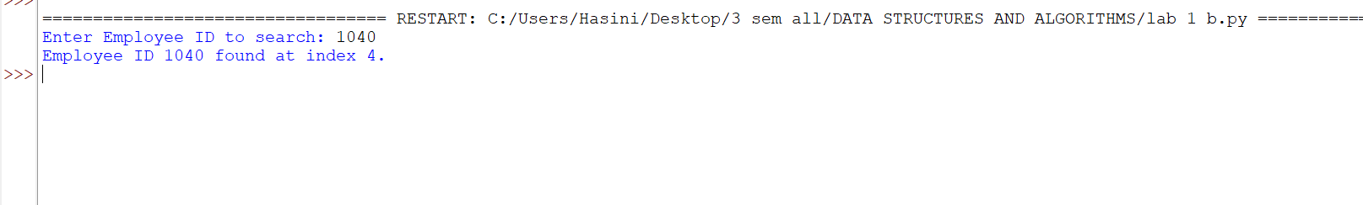

Output(-Ve Case):

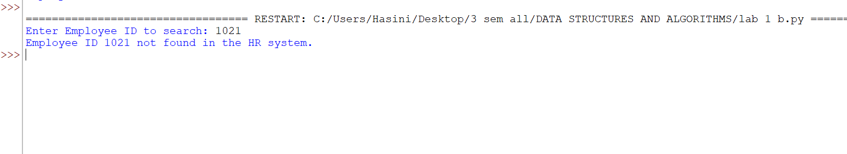

Explanation : Binary Search only works when the given array is in sorted order. Although the element 1021
Exists in the lists the program has returned that it doesn’t which is an error.

D.) Aim: Develop a python program to print 1st n terms of Fibonacci series.
Program:
def fib(n):
if(n < 0):
print("Please enter a +ve number")
return None
if (n == 0 or n == 1):
return n
else:
return fib(n-1)+fib(n-2)

n = int(input("Enter the number : "))
for i in range (n+1):
print(f"{fib(i)}",end = " ")
Output(+Ve Case):

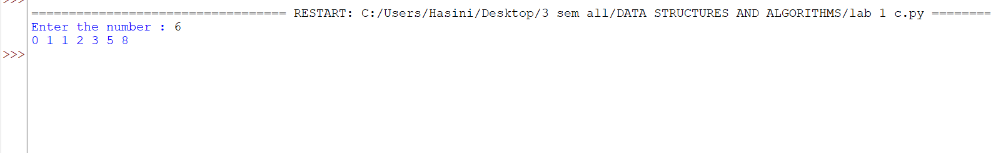

Output(-Ve Case):

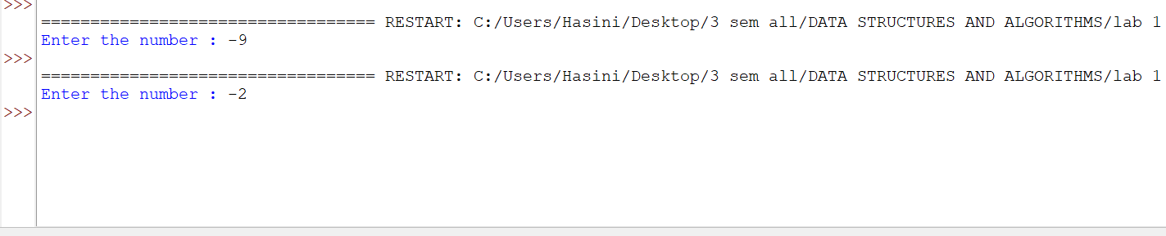

Explanation : a standard Fibonacci function should not accept negative numbers because negative inputs break the standard forward-sum logic and cause infinite loops.
E.) Aim: Develop a python program to calculate factorial of a given number.
Program:
def fac (n):
if n < 0 :
print("Please aenter a +ve number")
return None
if n == 0 or n == 1:
return 1
else:
return n*fac(n-1)

n = int(input("Enter a number : "))
print(f"The Factorial of {n} is {fac(n)}")

Output(+Ve Case):

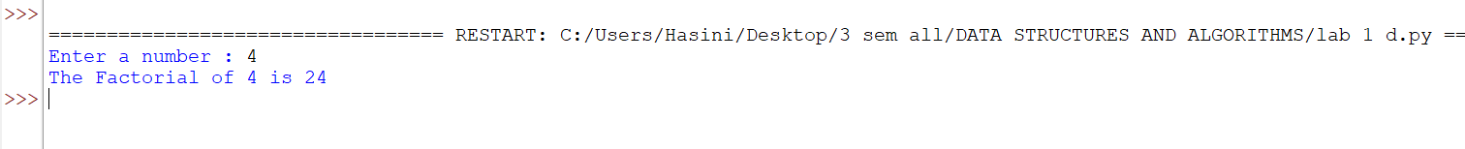

Output(-Ve Case):

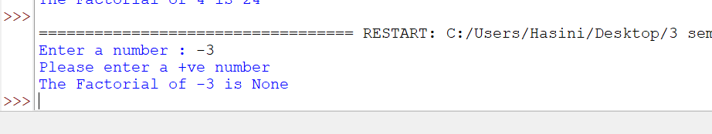

Explanation : The given Fibonacci sequence generator accepts only integer values giving values other than the integer data type such as float or special characters results in this type of Value Error.
LAB-2:
1.)Applying Searching Algorithms :
A.) Aim: Write a python program to implement linear search.
Program:
def lin_search(arr, key):
for i in range(len(arr)):
if arr[i] == key:
print(f"{key} at index {i}")
return
print(f"{key} not found")
n = int(input("Enter the number of elements: "))
arr = []
print("Enter elements:")
for i in range(n):
arr.append(int(input()))

key = int(input("Enter the key: "))
result = lin_search(arr, key)

Output(+Ve Case):

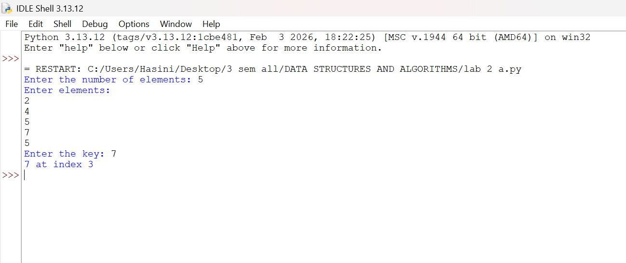

Output(-Ve Case):

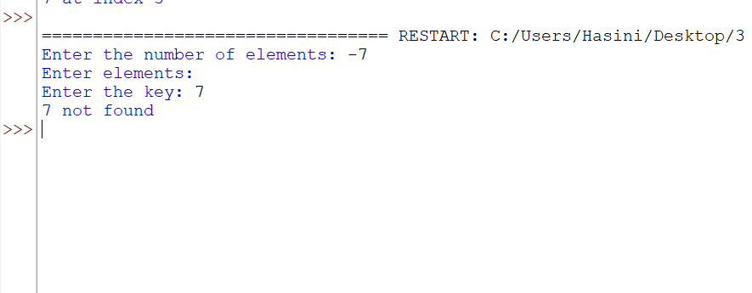

Explanation : The number of input elements should never be negative . In this case since input elements are -5 the program doesn’t allow me to enter any input elements nor is able to check the key given by the user.

B.)(i) Aim: Write a python program to implement binary search with sorted array as input.
Program:
def bin_search(arr,key):
low = 0
high = len(arr) - 1
while low <= high:
mid = (high+low)//2
if arr[mid] == key:
return mid
elif arr[mid] < key:
low = mid+1
else:
high = mid-1
return -1

n = int(input("Enter the number of elements: "))

arr = []

print("Enter elements:")
for i in range(n):
arr.append(int(input()))

key = int(input("Enter the key: "))

result = bin_search(arr, key)
if result!=-1:
print(f"Element found at index {result}")
else:
print("Element not found")
Output(+Ve Case):

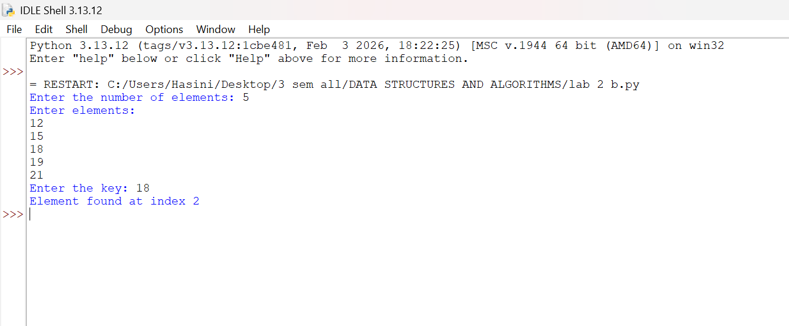

Output(-Ve Case):

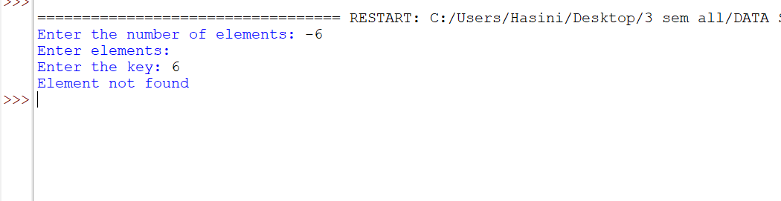

Explanation : The number of input elements should never be negative . In this case since input elements are -5 the program doesn’t allow me to enter any input elements nor is able to check the key given by the user.

(ii) Aim: Write a python program to implement binary search with unsorted array as input.
Program:
def bin_search(arr,key):
low = 0
high = len(arr) - 1
while low <= high:
mid = (high+low)//2
if arr[mid] == key:
return mid
elif arr[mid] < key:
low = mid+1
else:
high = mid-1
return -1

n = int(input("Enter the number of elements: "))

arr = []

print("Enter elements:")
for i in range(n):
arr.append(int(input()))
if arr == sorted(arr):
print("\n input list is already sorted")
else:
print("input list is not sorted")
print("sorting list....")
arr.sort()
print(f"Sorted List : {arr}")

key = int(input("Enter the key: "))

result = bin_search(arr, key)
if result!=-1:
print(f"Element found at index {result}")
else:
print("Element not found")

Output

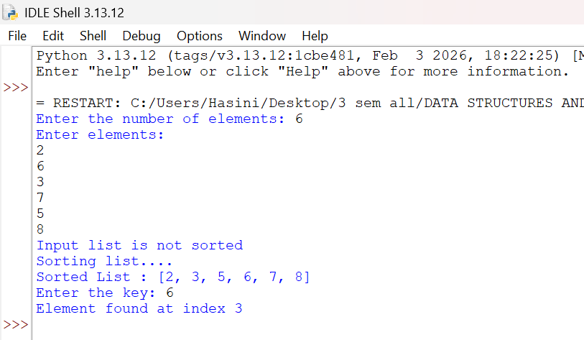

LAB-3:
1.)Applying Sorting Algorithms :
A.) Aim: Write a python program to apply bubble sort where input elements are taken from the user .
Program:
def bubble_sort(arr):
n = len(arr)
for i in range(n-1):
for j in range(n-i-1):
if arr[j] > arr[j+1]:
arr[j],arr[j+1] = arr[j+1],arr[j]
return arr
n = int(input("Enter the number of elements: "))
arr = []
print("Enter elements:")
for i in range(n):
arr.append(int(input()))
result = bubble_sort(arr)
print(f"Sorted array : {result}")

Output
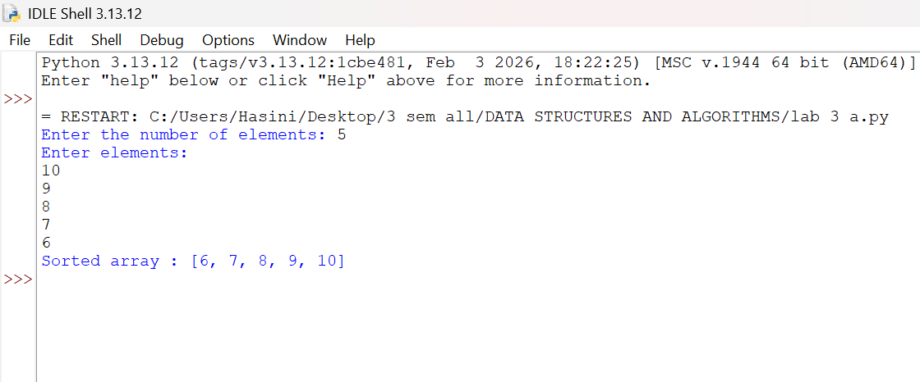

B.) Aim: Write a python program to apply insertion sort where input elements are taken from the user .
Program:
def insertion_sort(arr):
n = len(arr)
for i in range(1,n):
key = arr[i]
j = i-1
while j >= 0 and arr[j] > key:
arr[j+1] = arr[j]
j = j-1
arr[j+1] = key
return arr
n = int(input("Enter the number of elements: "))
arr = []
print("Enter elements:")
for i in range(n):
arr.append(int(input()))
result = insertion_sort(arr)
print(f"Sorted array : {result}")
Output

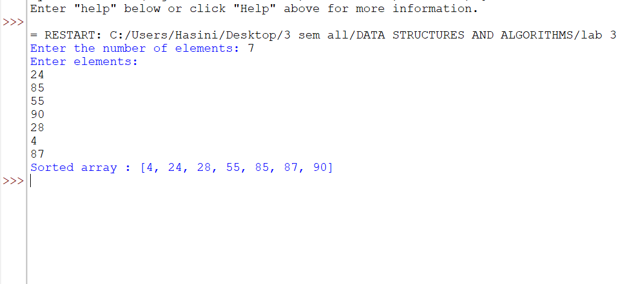

C.) Aim: Write a python program to apply selection sort where input elements are taken from the user .
Program:
def selection_sort(arr):
n = len(arr)
for i in range(n-1):
min_index = i
for j in range (i+1,n):
if arr[j] < arr[min_index]:
min_index = j
arr[i],arr[min_index] = arr[min_index],arr[i]
return arr
n = int(input("Enter the number of elements: "))
arr = []
print("Enter elements:")
for i in range(n):
arr.append(int(input()))
result = selection_sort(arr)
print(f"Sorted array : {result}")

Output:

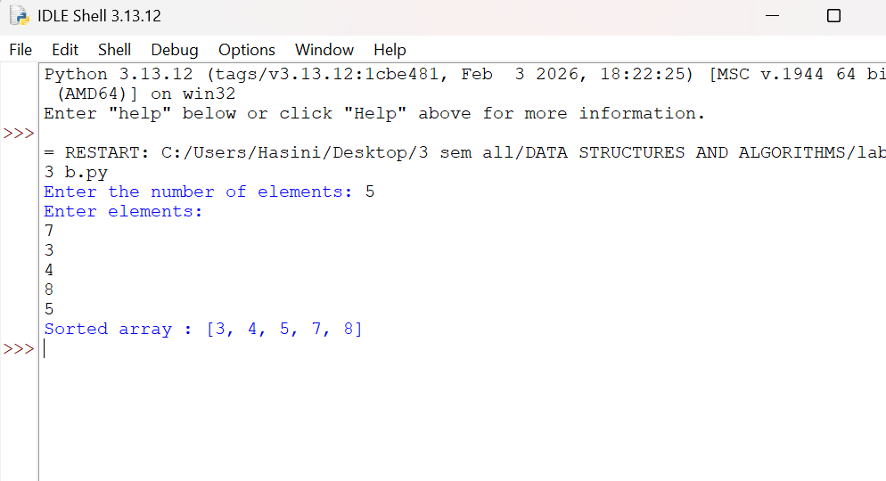
LAB-4:

A.) Aim: write a python program to implement quick sort, where the elements are taken from user.
Program:
def quicksort(a,low,high):
if low < high:
i = low
j = high
pivot = low
while i < j:
while i < len(a) and a[i] <= a[pivot]:
i+=1
while a[j] > a[pivot]:
j-=1
if i < j:
a[i],a[j] = a[j],a[i]
a[j],a[pivot] = a[pivot],a[j]
quicksort(a,low,j-1)#Left Part
quicksort(a,j+1,high)#Right Part

#Entering the Elements
n = int(input("Enter the number of elements: "))
a = []
print("Enter elements:")
for i in range(n):
a.append(int(input()))
quicksort(a, 0, n - 1)
print("Sorted Array :.......")
print(a)
Output:
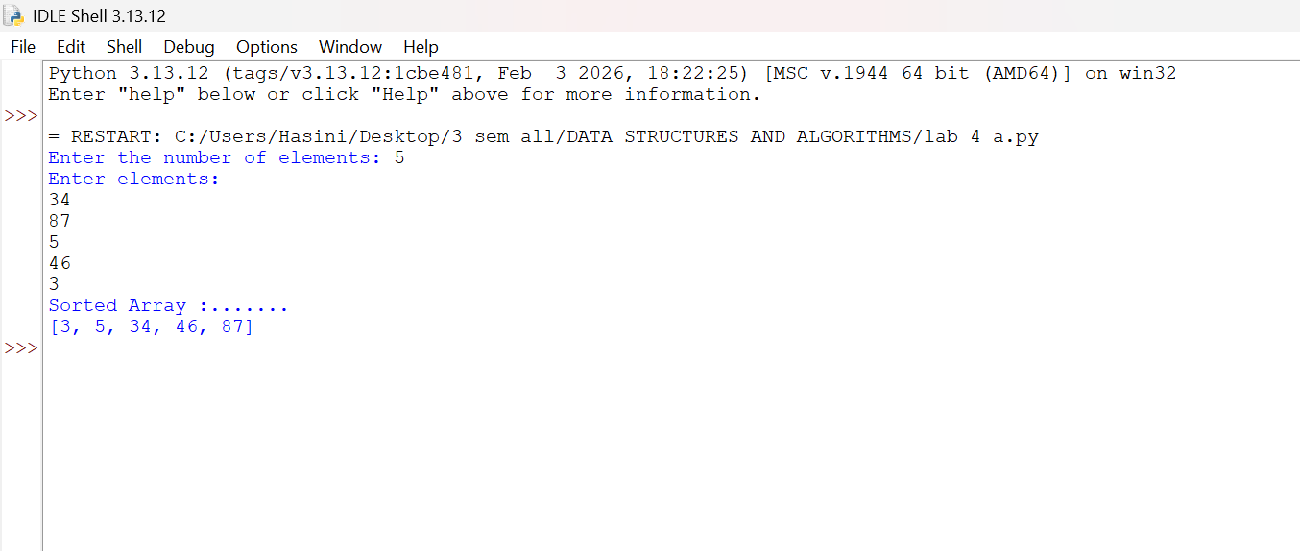

B.) Aim: write a python program to implement merge sort, where the elements are taken from user.
Program:
def merge_sort(arr):
# Base Condition
if len(arr) <= 1:
return arr
# Divide Array
mid = len(arr) // 2
left = arr[:mid]
right = arr[mid:]
# Recursive calls
merge_sort(left)
merge_sort(right)
# Merge sorted halves
i = j = k = 0
while i < len(left) and j < len(right):
if left[i] <= right[j]:
arr[k] = left[i]
i += 1
else:
arr[k] = right[j]
j += 1
k += 1
# Copy remaining elements from Left Array
while i < len(left):
arr[k] = left[i]
i += 1
k += 1
# Copy remaining elements from Right Array
while j < len(right):
arr[k] = right[j]
j += 1
k += 1
return arr
n = int(input("Enter the number of elements: "))
arr = []
print("Enter elements:")
for i in range(n):
arr.append(int(input()))
print("Sorted Array :.......")
print(merge_sort(arr))

Output:

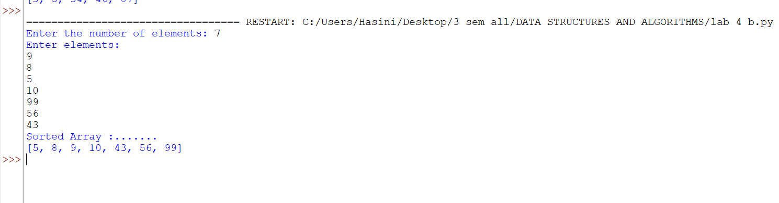
LAB-5:
Aim: A) Write a python program to implement a circular linked list with the below operations: A.create linked list B.insert at beginning C.Insert at end D.Insert at index E.Delete by value F.Delete first node G.Delete last node H.Count number of nodes I.Display/traverse J.exit
Program:
class Node:
#[cite: 12]
def __init__(self, data):
self.data = data
self.next = None
class CircularLinkedList:
#[cite: 12]
def __init__(self):
self.head = None
self.tail = None
# Insert at Beginning[cite: 13]
def insert_begin(self, data):
new = Node(data)
# Case 1: Empty list
if self.head is None:
self.head = new
self.tail = new
new.next = self.head
# Case 2: Non-empty list
else:
new.next = self.head
self.head = new
self.tail.next = self.head
# Insert at End[cite: 14]
def insert_end(self, data):
new = Node(data)
# Case 1: Empty list
if self.head is None:
self.head = new
self.tail = new
new.next = self.head
# Case 2: Non-empty list
else:
new.next = self.head
self.tail.next = new
self.tail = new
# Insert at Particular Position[cite: 15]
# Position starts from 0
def insert_position(self, position, data):
# Insert at beginning
if position == 0:
self.insert_begin(data)
return
if self.head is None or position < 0:
print("Invalid position")
return
new = Node(data)
temp = self.head
# Move to the node before the required position[cite: 16]
for i in range(position - 1):
temp = temp.next
# We have completed one circle
if temp == self.head:
print("Invalid position")
return
# Insert new node
new.next = temp.next
temp.next = new
# If inserted after tail, update tail
if temp == self.tail:
self.tail = new
# Delete at Beginning[cite: 17]
def delete_begin(self):
if self.head is None:
print("List is empty")
return
# Only one node
if self.head == self.tail:
self.head = None
self.tail = None
# More than one node
else:
self.head = self.head.next
self.tail.next = self.head
# Delete at End[cite: 18]
def delete_end(self):
if self.head is None:
print("List is empty")
return
# Only one node
if self.head == self.tail:
self.head = None
self.tail = None
return
# Find node before tail
temp = self.head
while temp.next != self.tail:
temp = temp.next
temp.next = self.head
self.tail = temp
# Traverse the Circular Linked List[cite: 19]
def traverse(self):
if self.head is None:
print("List is empty")
return
temp = self.head
while True:
print(temp.data, end=" -> ")
temp = temp.next
if temp == self.head:
break
print("(back to head)")

# Display Head and Tail[cite: 20]
def display_head_tail(self):
if self.head is None:
print("List is empty")
else:
print("Head =", self.head.data)
print("Tail =", self.tail.data)
print("Tail.next =", self.tail.next.data)
# Menu-driven implementation
if __name__ == "__main__":
cll = CircularLinkedList()
while True:
print("\n--- Circular Linked List Menu ---")
print("1. Insert at Beginning")
print("2. Insert at End")
print("3. Insert at Position")
print("4. Delete at Beginning")
print("5. Delete at End")
print("6. Traverse List")
print("7. Display Head and Tail")
print("8. Exit")
ch = int(input("Enter your choice: "))
if ch == 1:
x = int(input("Value: "))
cll.insert_begin(x)
elif ch == 2:
x = int(input("Value: "))
cll.insert_end(x)
elif ch == 3:
pos = int(input("Position (starts from 0): "))
x = int(input("Value: "))
cll.insert_position(pos, x)
elif ch == 4:
cll.delete_begin()
elif ch == 5:
cll.delete_end()
elif ch == 6:
cll.traverse()
elif ch == 7:
cll.display_head_tail()
elif ch == 8:
print("Exiting...")
break
else:
print("Invalid choice, please try again." )

Output:
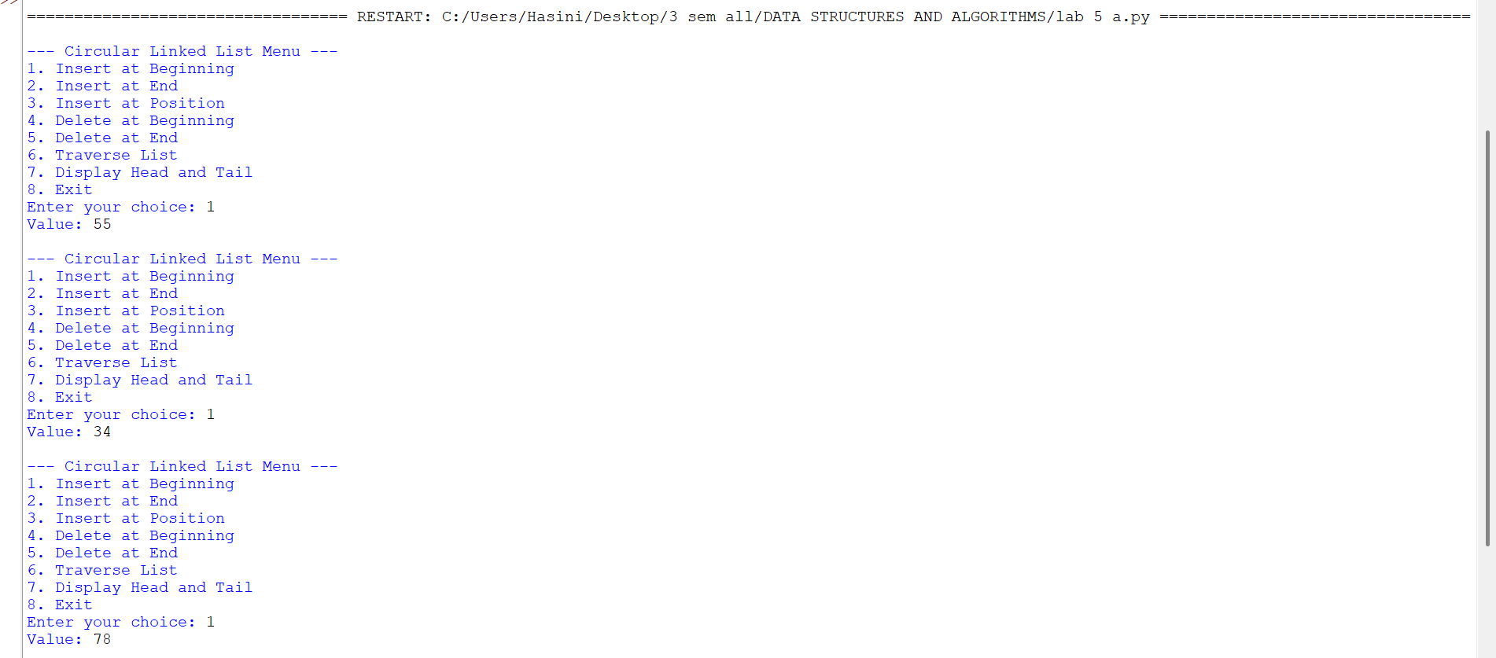

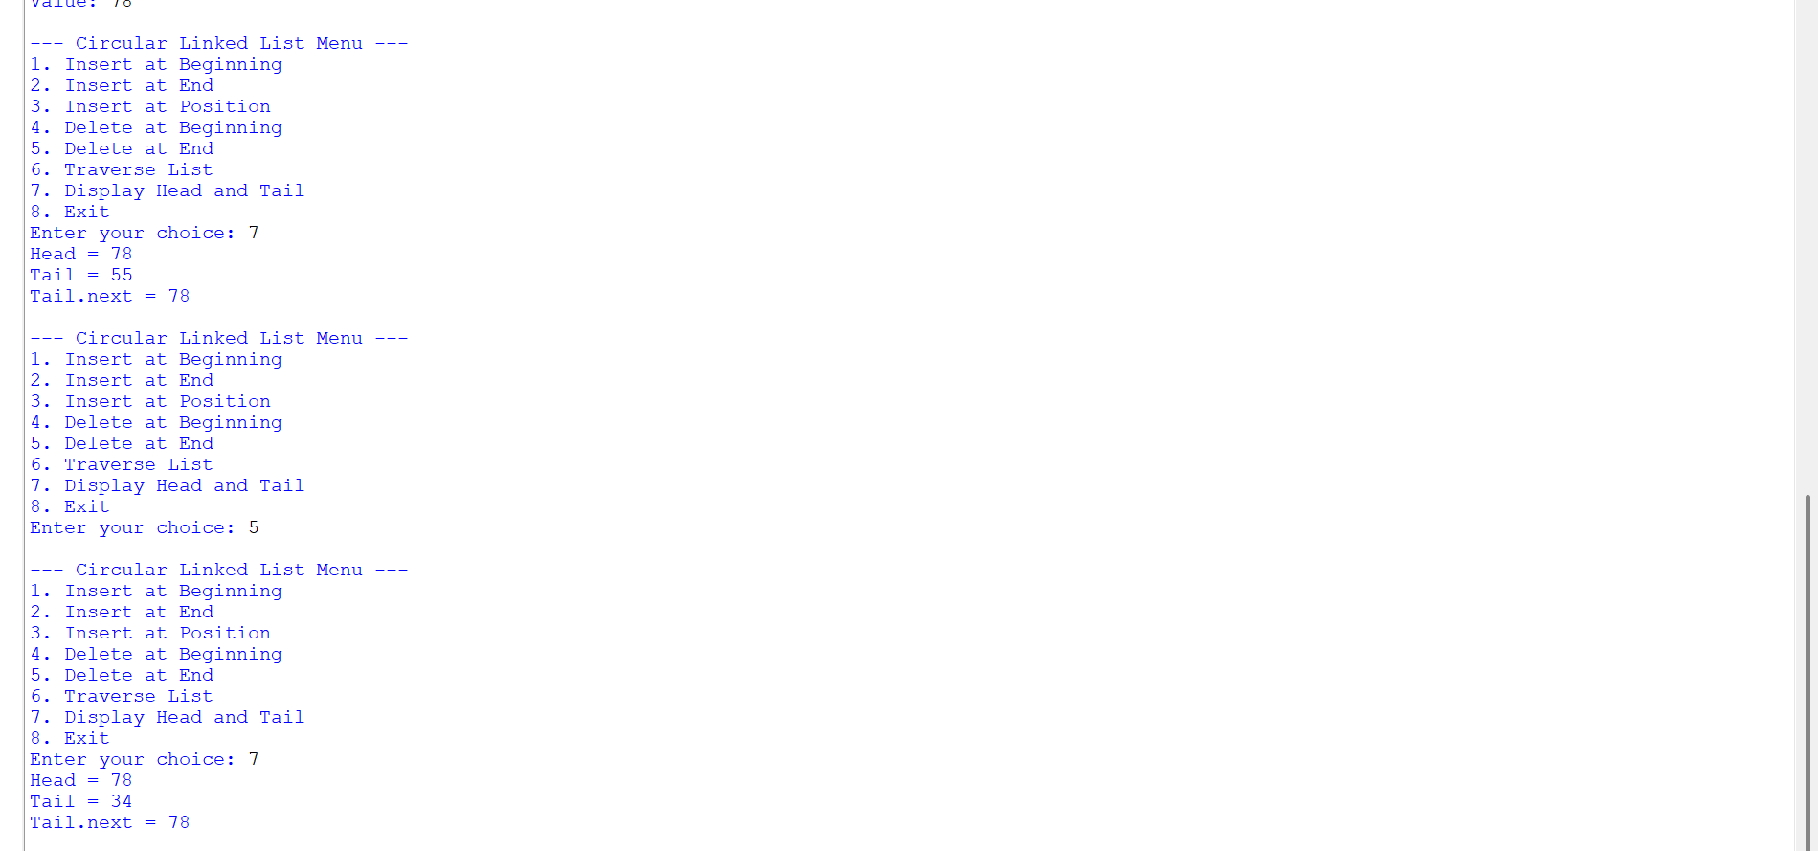
B.) Aim: Write a python program to implement a single linked list with the below operations: A.create linked list B.insert at beginning C.Insert at end D.Insert at index E.Delete by value F.Delete first node G.Delete last node H.Count number of nodes I.Display/traverse J.exit
Program:
class Node:
def __init__(self, data):
self.data = data
self.next = None
class SinglyLinkedList:
def __init__(self):
self.head = None
def create(self):
n = int(input(("Enter number of elements:")))
for i in range(n):
x = int(input(("Enter value:")))
new = Node(x)
if self.head is None:
self.head = new
else:
temp = self.head
while temp.next:
temp = temp.next
temp.next = new
def insert_begin(self, data):
new = Node(data)
new.next = self.head
self.head = new
def insert_end(self, data):
new = Node(data)
if self.head is None:
self.head = new
else:
temp = self.head
while temp.next:
temp = temp.next
temp.next = new
def insert_index(self, index, data):
if index == 0:
self.insert_begin(data)
return
elif index > self.count() or index < 0:
print("Invalid Index")
return
new = Node(data)
temp = self.head
for i in range(index - 1):
temp = temp.next
new.next = temp.next
temp.next = new
def deleteAtBeg(self):
if self.head is None:
print("No Data to delete")
else:
temp = self.head
self.head = temp.next
print("Deleted Value = ",temp.data)
def deleteAtEnd(self):
if self.head is None:
print("No Data to delete")
elif self.head.next is None:
self.head = None
else:
temp = self.head
temp1 = temp
while temp.next:
temp1 = temp
temp = temp.next
temp1.next = None
def delete(self, value):
if self.head is None:
print("No Data to delete")
else:
temp = self.head
if temp and temp.data == value:
self.head = temp.next
print("Value deleted")
return
while temp.next and temp.next.data != value:
temp = temp.next
if temp.next is None:
print("Value not present")
else:
temp.next = temp.next.next
print("Value deleted")
def display(self):
if self.head is None:
print("No Data")
else:
temp = self.head
while temp:
print(temp.data, end=" -> ")
temp = temp.next
print("None")
def count(self):
if self.head is None:
print("No Linked List")
return 0
else:
c = 0
temp = self.head
while temp:
c += 1
temp = temp.next
print(f"Number of nodes = {c}")
return c
# Menu-driven implementation matching the provided snippet
if __name__ == "__main__":
sll = SinglyLinkedList()
while True:
print("\n1. Create\n2. Insert at Beginning\n3. Insert at End\n4. Insert at Index\n5. Delete Value\n6. Delete at Beginning\n7. Delete at End\n8. Count\n9. Display\n10. Exit")
ch = int(input("Enter choice: "))
if ch == 1:
sll.create()
elif ch == 2:
x = int(input("Value: "))
sll.insert_begin(x)
elif ch == 3:
x = int(input("Value: "))
sll.insert_end(x) elif ch == 4:
idx = int(input("Index: "))
x = int(input("Value: "))
sll.insert_index(idx, x)
elif ch == 5:
x = int(input("Delete value: "))
sll.delete(x)
elif ch == 6:
sll.deleteAtBeg()
elif ch == 7:
sll.deleteAtEnd()
elif ch == 8:
sll.count()
elif ch == 9:
sll.display()
elif ch == 10:
break Output:

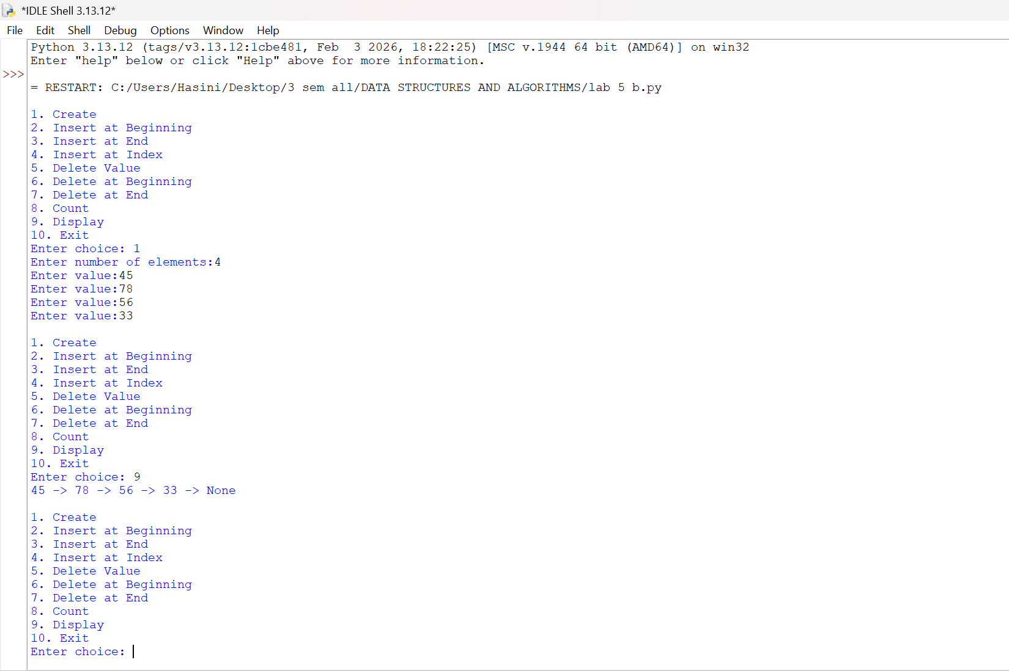
LAB-6:
- Aim: Write a python program to implement stack operations such as push, pop, peek, display using linked list.

Program:
class Node:
def __init__(self, data):
self.data = data
self.next = None
class Stack:
def __init__(self):
self.top = None
def push(self, data):
new = Node(data)
new.next = self.top
self.top = new
print(data, "pushed into stack")
def pop(self):
if self.top is None:
print("Stack Underflow")
else:
print(self.top.data, "popped from stack")
self.top = self.top.next
def peek(self):
if self.top is None:
print("Stack is empty")
else:
print("Top element:", self.top.data)
def display(self):
if self.top is None:
print("Stack is empty")
else:
temp = self.top
print("Stack elements:")
while temp is not None:
print(temp.data)
temp = temp.next
s = Stack()
while True:
print("\n--- STACK USING LINKED LIST ---")
print("1. Push")
print("2. Pop")
print("3. Peek")
print("4. Display")
print("5. Exit")
choice = int(input("Enter your choice: "))
if choice == 1:
data = int(input("Enter the element: "))
s.push(data)
elif choice == 2:
s.pop()
elif choice == 3:
s.peek()
elif choice == 4:
s.display()
elif choice == 5:
print("Program terminated")
break
else:
print("Invalid choice")

Output:
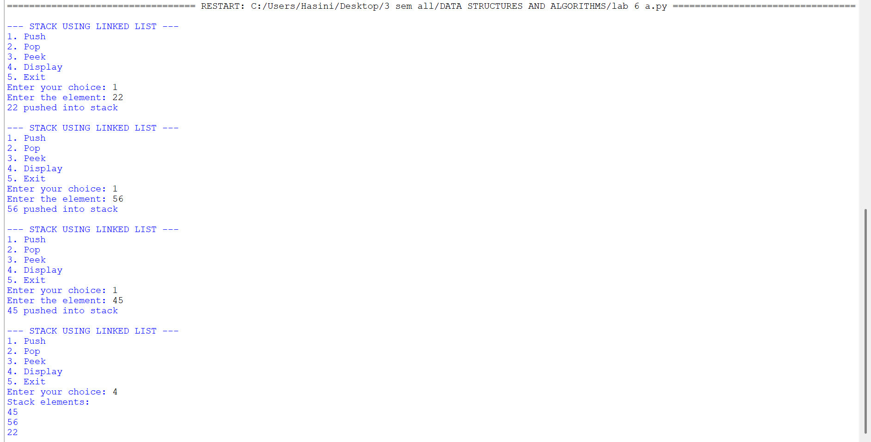

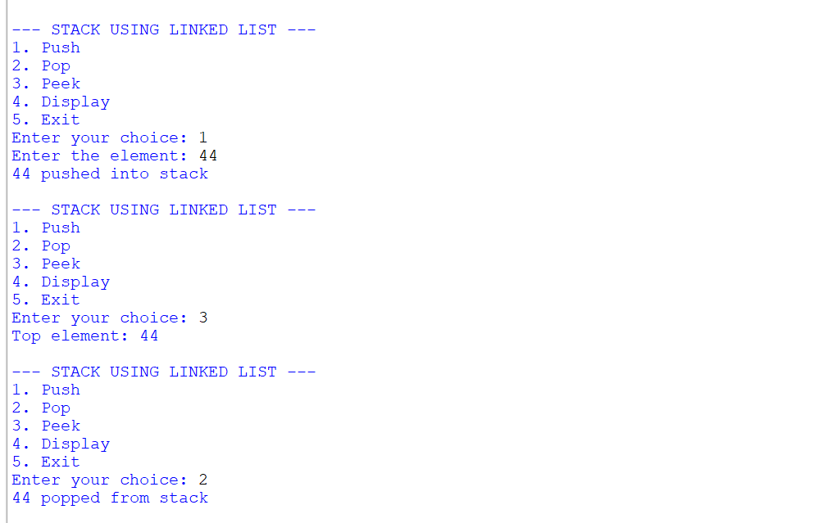

- Aim: Write a python program to implement stack operations such as push, pop, peek, display using an array.

Program:
class StackEx:
#
def __init__(self, size):
self.size = size
self.stack = [None] * size
self.top = -1

# Push operation
def push(self, item):
if self.top == self.size - 1:
print("Stack Overflow")
else:
self.top += 1
self.stack[self.top] = item
print(item, "pushed into the stack")

# Pop operation
def pop(self):
if self.top == -1:
print("Stack Underflow")
else:
item = self.stack[self.top]
self.stack[self.top] = None
self.top -= 1
print(item, "popped from the stack")

# Peek operation
def peek(self):
if self.top == -1:
print("Stack is empty")
else:
print("Top element:", self.stack[self.top])

# Display operation
def display(self):
if self.top == -1:
print("Stack is empty")
else:
print("The elements of the stack are:")
for i in range(self.top, -1, -1):
print(self.stack[i])

# Create stack
size = int(input("Enter the size of the stack: "))
s = StackEx(size)
while True:
print("\n----- STACK MENU -----")
print("1. Push")
print("2. Pop")
print("3. Peek")
print("4. Display")
print("5. Exit")
choice = int(input("Enter your choice: "))
if choice == 1:
item = int(input("Enter the element to push: "))
s.push(item)
elif choice == 2:
s.pop()
elif choice == 3:
s.peek()
elif choice == 4:
s.display()
elif choice == 5:
print("Program terminated.")
break
else:
print("Invalid choice")

Output:

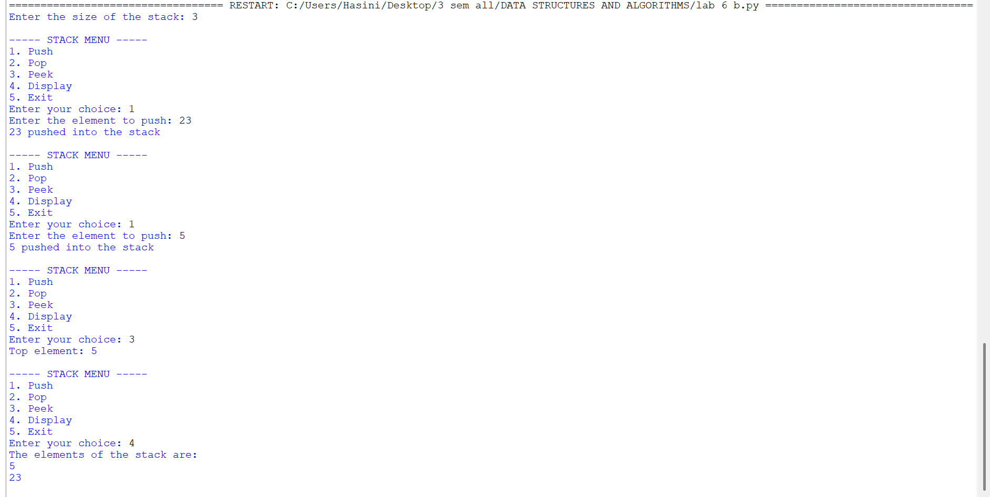
LAB-7:
A.) Aim: Write a python program to implement queue and its operations such as enqueue, dequeue, peek and display with a menu driven approach using an array
Program:
class Node:
def __init__(self, data):
self.data = data
self.next = None
class QueueEx:
def __init__(self):
self.front = None
self.rear = None
def enqueue(self, x):
new = Node(x)
if self.rear is None:
self.front = self.rear = new
else:
self.rear.next = new
self.rear = new
print(item, "inserted into the queue")
def dequeue(self):
if self.front is None:
print("Queue underflow")
else:
x = self.front.data
self.front = self.front.next
if self.front is None:
self.rear = None
print(f"{x} deleted from the queue")

def peek(self):
if self.front is None:
print("Queue is empty")
else:
print("Front element:", self.front.data)
def display(self):
if self.front is None:
print("Queue is empty")
else:
temp = self.front
print("Queue elements are:")
while temp:
print(temp.data, end=" ")
temp = temp.next
print()
q = QueueEx()
while True:
print("\n----- QUEUE MENU -----")
print("1. Enqueue")
print("2. Dequeue")
print("3. Peek")
print("4. Display")
print("5. Exit")
choice = int(input("Enter your choice: "))
if choice == 1:
item = int(input("Enter the element to enqueue: "))
q.enqueue(item)
elif choice == 2:
q.dequeue()
elif choice == 3:
q.peek()
elif choice == 4:
q.display()
elif choice == 5:
print("Program terminated.")
break
else:
print("Invalid choice")

Output:

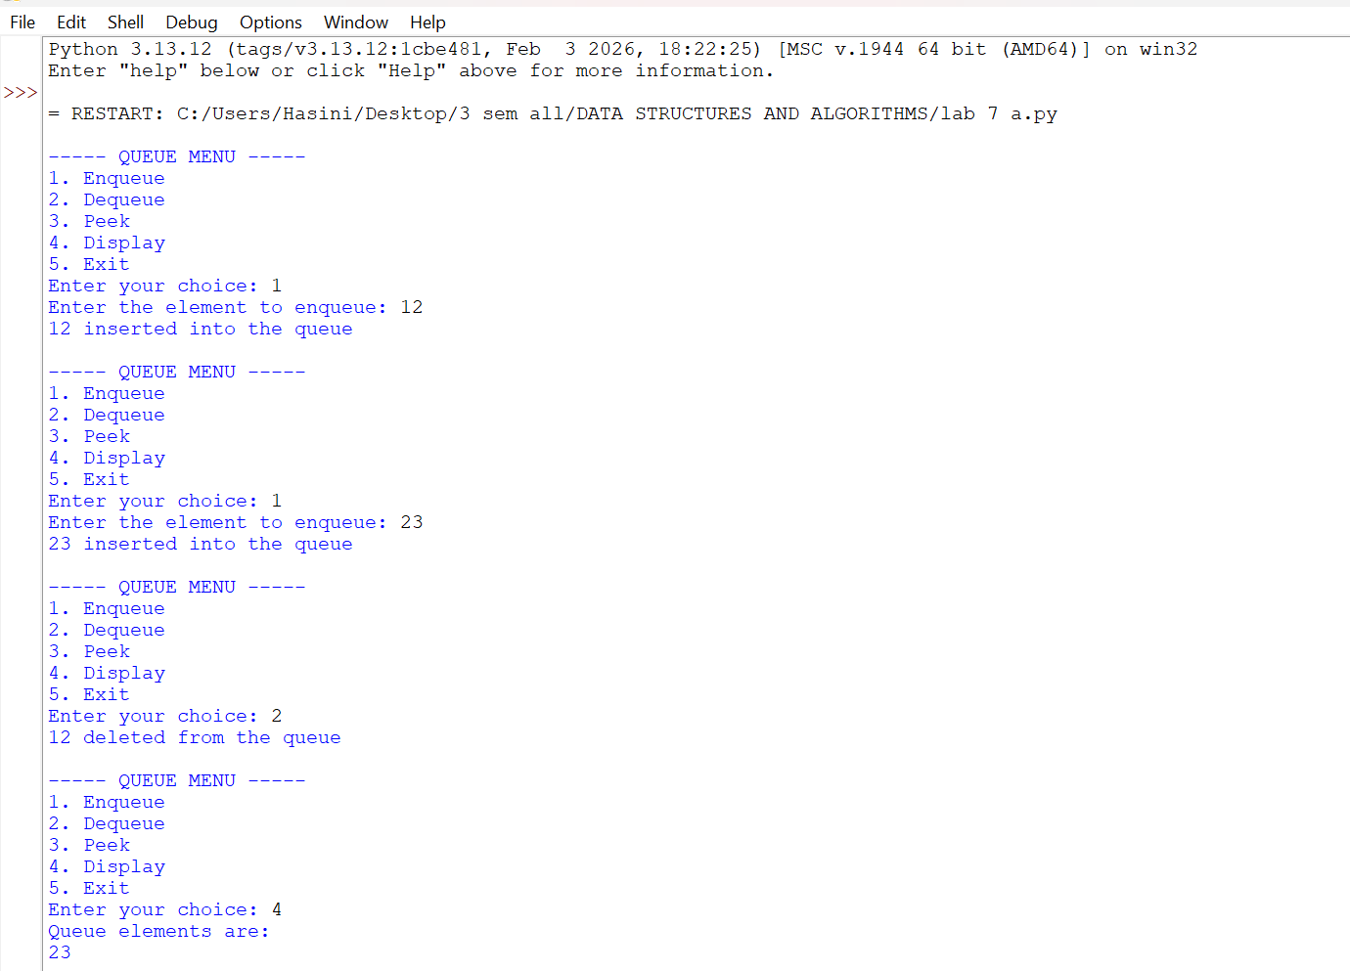
B.) Aim: Write a python program to implement queue and its operations such as enqueue, dequeue, peek and display with a
Circular queue
Program:
class CircularQueue:
def __init__(self, size):
self.size = size
self.queue = [None] * size
self.front = -1
self.rear = -1
def enqueue(self, item):
if (self.rear + 1) % self.size == self.front:
print("Queue Overflow")
elif self.front == -1:
self.front = 0
self.rear = 0
self.queue[self.rear] = item
print(item, "inserted into the queue")
else:
self.rear = (self.rear + 1) % self.size
self.queue[self.rear] = item
print(item, "inserted into the queue")
def dequeue(self):
if self.front == -1:
print("Queue Underflow")
# Only one element is present
elif self.front == self.rear:
item = self.queue[self.front]
self.queue[self.front] = None
self.front = -1
self.rear = -1
print(item, "deleted from the queue")
# More than one element
else:
item = self.queue[self.front]
self.queue[self.front] = None
self.front = (self.front + 1) % self.size
print(item, "deleted from the queue")
# Display operation
def display(self):
if self.front == -1:
print("Queue is empty")
else:
print("The elements of the queue are:")
i = self.front
while True:
print(self.queue[i])
if i == self.rear:
break
i = (i + 1) % self.size
# Create Circular Queue
size = int(input("Enter the size of the queue: "))
q = CircularQueue(size)
while True:
print("\n----- CIRCULAR QUEUE MENU -----")
print("1. Enqueue")
print("2. Dequeue")
print("3. Display")
print("4. Exit")
choice = int(input("Enter your choice: "))

if choice == 1:
item = int(input("Enter the element to enqueue: "))
q.enqueue(item)
elif choice == 2:
q.dequeue()
elif choice == 3:
q.display()
elif choice == 4:
print("Program terminated.")
break
else:
print("Invalid choice")

Output:

